Chapter 8, Problem 11.

The natural response of an RLC circuit is described by the differential equation

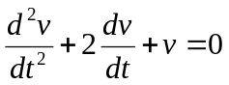

for which the initial conditions are v(0) = 10 and dv(0)/dt = 0. Solve for v(t).

